Task 1 B

Page Visualisation

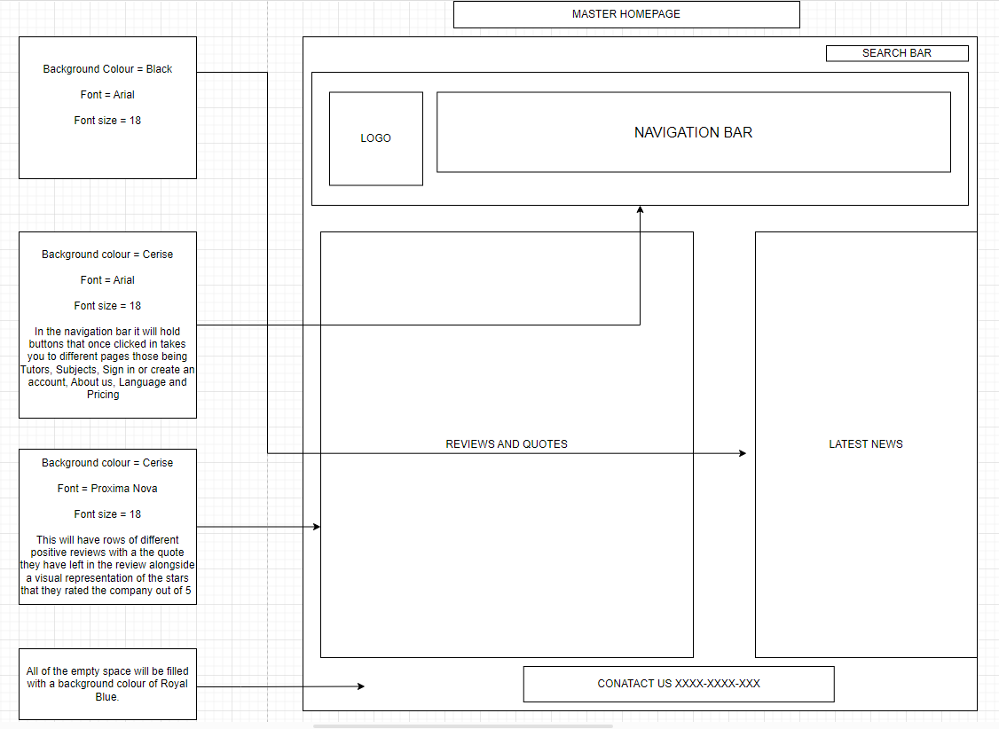

Sign – Up Page

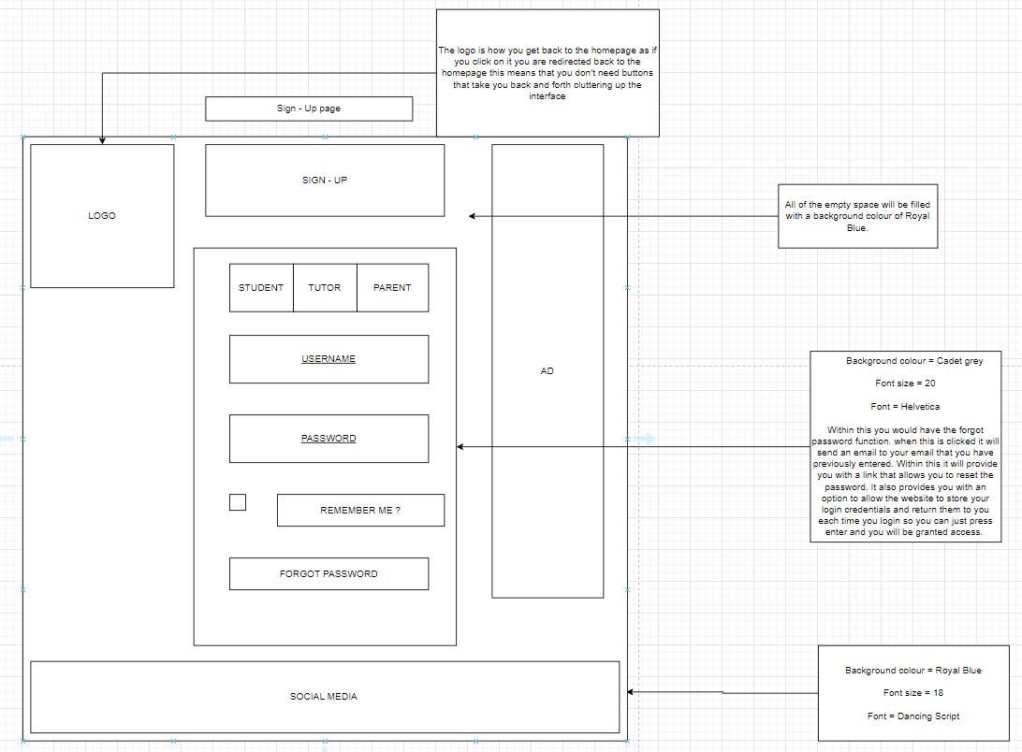

Flowchart

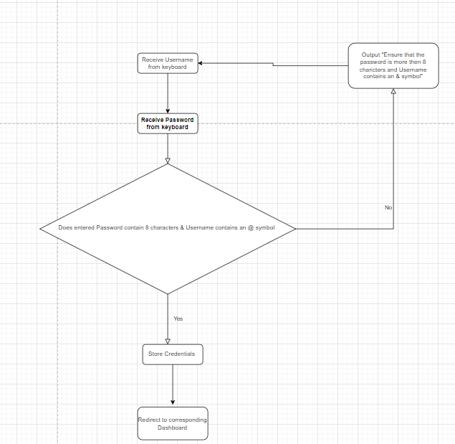

Log – In Page

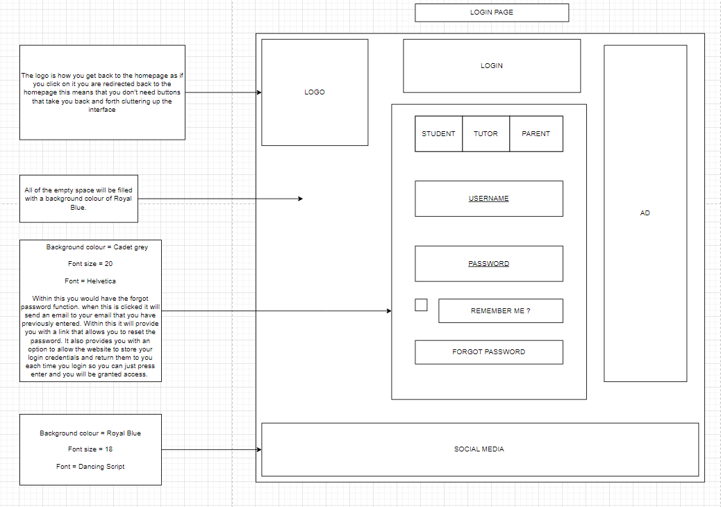

|  |  |  |  |  |
| --- | --- | --- | --- | --- |
| Field name | Data Type | Field Length | Constrains | Descriptions |
| Username | String | 30 | Primary Key | This is entered by the client and is how they will gain access to their account |
| Password | String | 30 | Not Null | This is the password that is inputted by the user. |

Flowchart

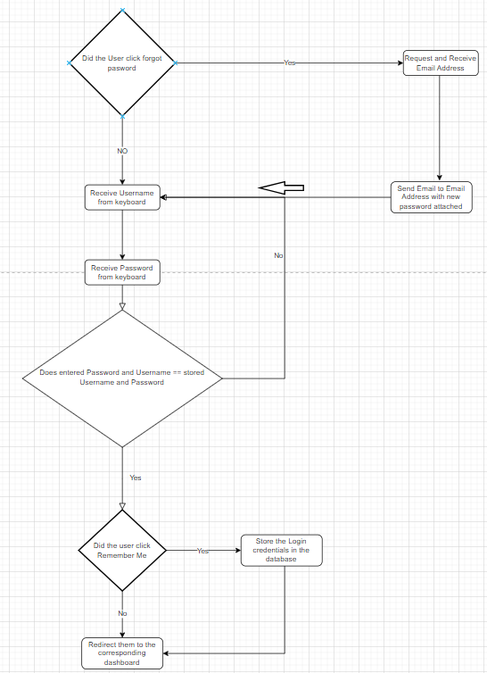

|  |  |  |  |  |
| --- | --- | --- | --- | --- |
| Field name | Data Type | Field Length | Constrains | Descriptions |
| Username | String | 30 | Primary Key | This is entered by the client and is how they will gain access to their account |
| Password | String | 30 | Not Null | This is the password that is inputted by the user. |

Student Dashboard

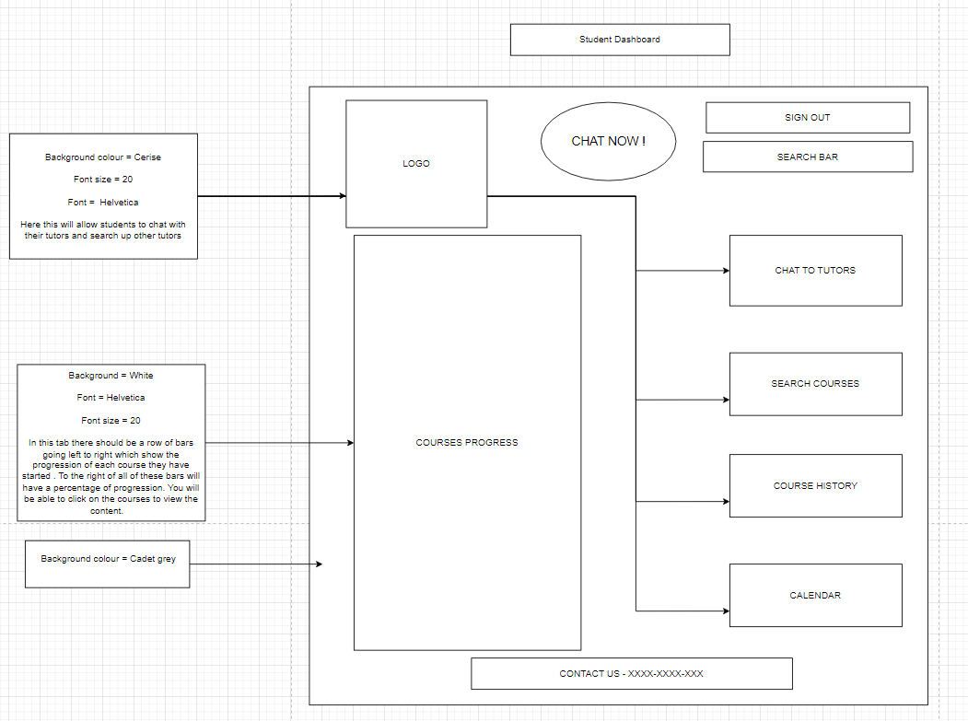

Parent Dashboard

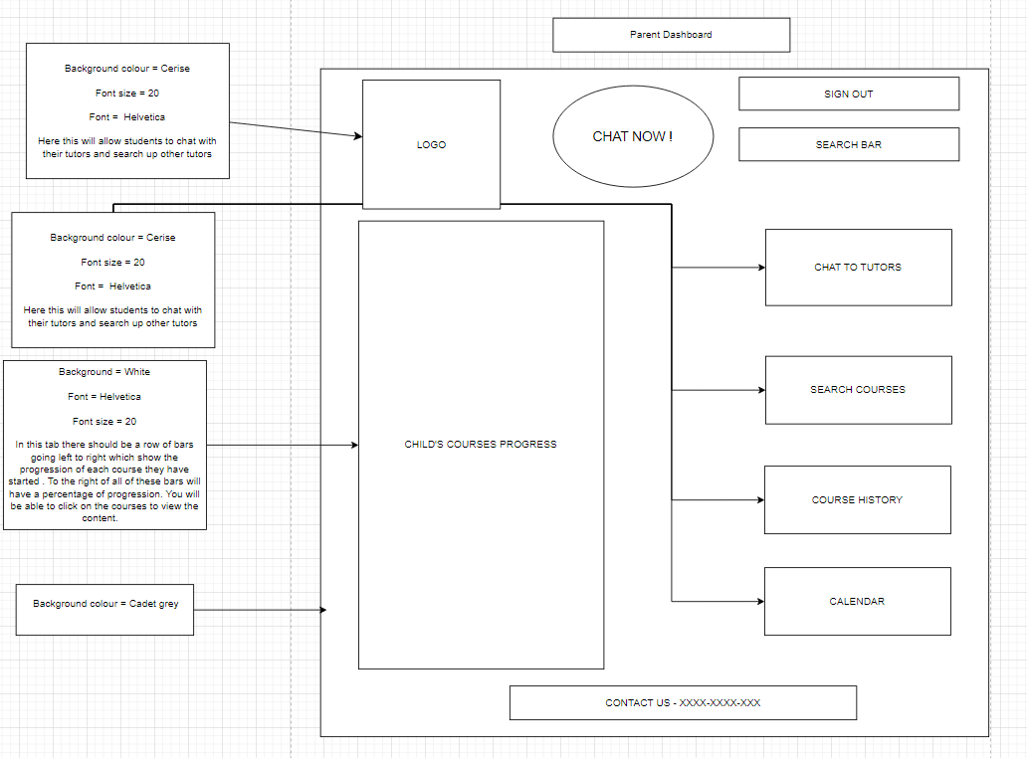

Tutor Dashboard

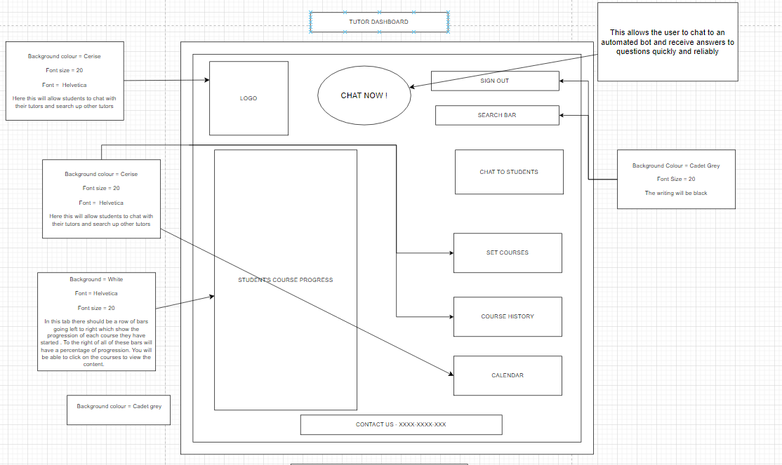

Services

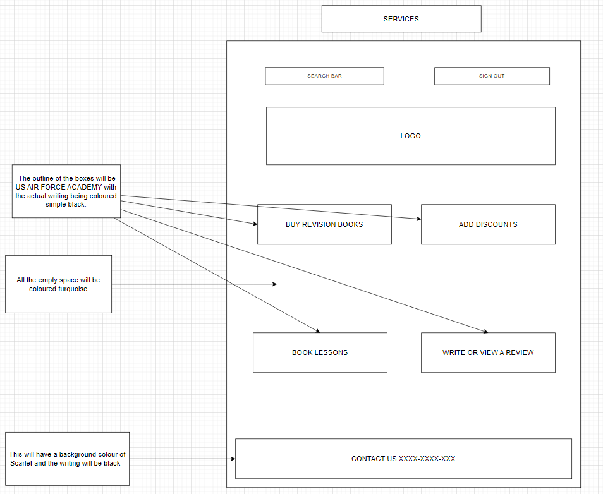

About Us

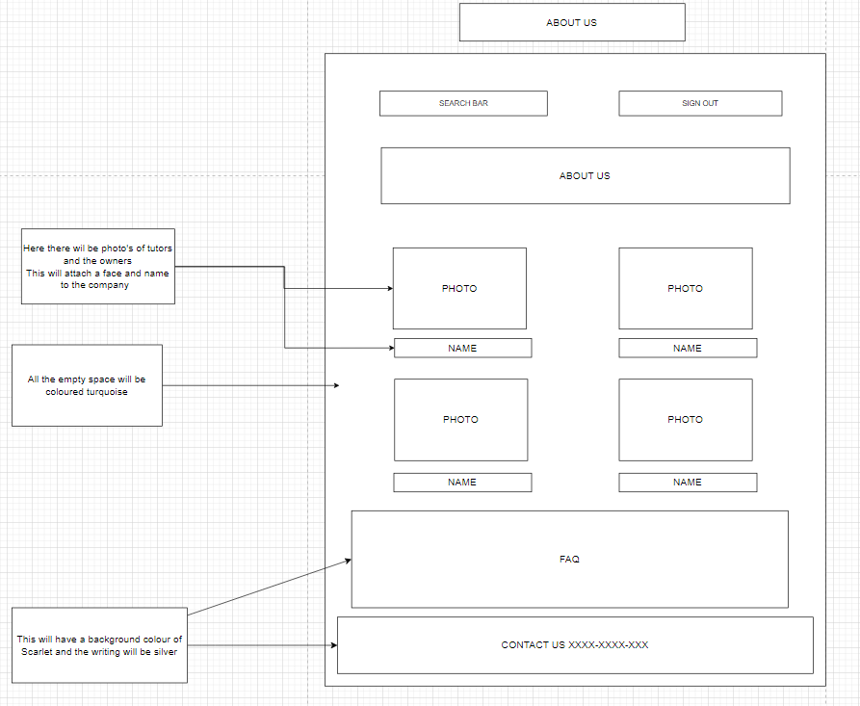

Booking

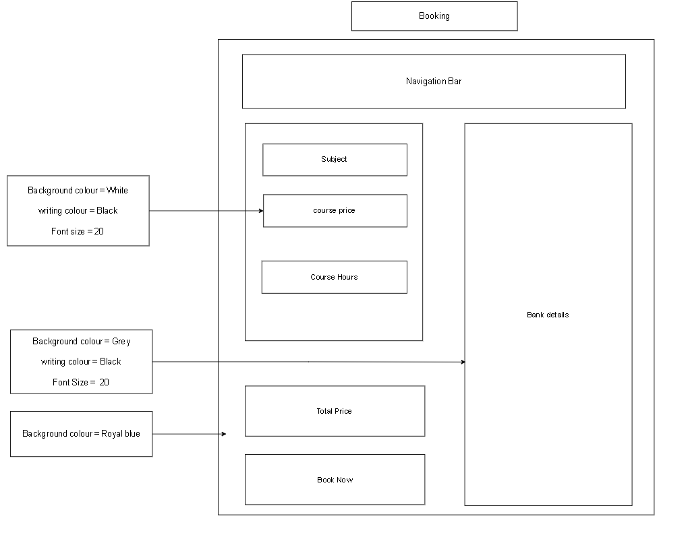

Navigation Map

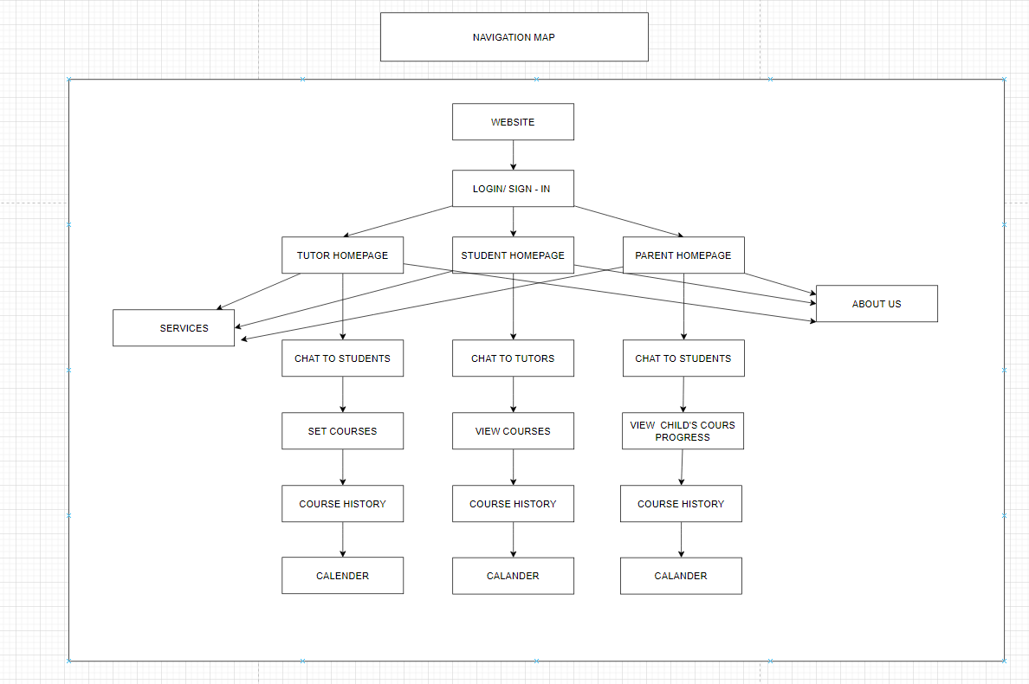

Test strategies

|  |  |  |  |  |
| --- | --- | --- | --- | --- |
| Date of test | what need to be tested | Types of tests | Dependencies | Information |
| N/A | The product as a whole | Alpha testing |  | This is done by the developers by using the documented test plans |
|  | The product as a whole | Beta Testing |  | This is done by a range of users and can act as a blanket testing strategy as it is so vast |
| N/A | The back – end code and how the product works within the website | Blackbox testing |  | This is done in order to test everything within the website. The things that end users don’t see are often more important than what they see so it is vital it is done correctly |
| N/A | The looks of the website. This would also be the UI and UX design | Whitebox testing |  | This is a test that covers everything that the end user sees this is important as if their experience is bad then there are unlikely to return |
| N/A | The overall product at the end of development | Acceptance testing |  | This is done at the end of the testing as it is the final check to see if the end product meets the requirements for it to go online |
| N/A | The security of the website | White hacking |  | This is done by paying hackers to see if they are able to find any weak points in the system that can be hacked and exploited. |

Data Requirements

|  |  |
| --- | --- |
| User information | |
| First name | Data Type |
| Surname | String |
| Phone number | String |
| Email Address | String |

|  |  |
| --- | --- |
| User Login | |
| Username | String |
| Password | String |

|  |  |
| --- | --- |
| Account information | |
| Account number | String |
| Expiry date | String |
| Account holders name | String |
| Security number | String |
| Credit card number | String |

2